**SUPPLEMENTARY MATERIALS**

**Combined climate and nutritional performance of seafoods**

**SEAFOODS ANALYZED**

The seafoods analyzed are shown in Table S1. The selection of seafoods was based on the availability of nutrition data for raw edible meat of the species in the food database of the Swedish Food Agency (SFA, 2018). A total of 37 out of the 145 seafoods available in the food database were included in the analysis. Cooked and prepared seafoods were excluded. A smaller number of products were also excluded because they are not relevant in Swedish seafood production or consumption (e.g. farmed cod, farmed Atlantic halibut, wild caught Atlantic salmon, wild caught rainbow trout, wild caught trout, common bream, vendace, fresh water ling, blue crab). Monkfish was excluded because data could not be found for all nutrients analyzed.

Table S1. Seafoods analyzed

|  |  |  |
| --- | --- | --- |
| Species common name | Scientific name | Seafood category |
| Alaskan pollock | *Theragra chalcogramma* | Cods, hakes, etc. |
| Arctic char | *Salvelinus alpinus* | Salmon, trout |
| Atlantic cod | *Gadus morhua* | Cods, hakes, etc. |
| Atlantic halibut | *Hippoglossus hippoglossus* | Flatfishes |
| Atlantic herring | *Clupea harengus* | Herrings, mackerels, etc. |
| Atlantic herring from the Baltic Sea | *Clupea harengus* | Herrings, mackerels, etc. |
| Atlantic mackerel | *Scomber scombrus* | Herrings, mackerels, etc. |
| Atlantic salmon | *Salmo salar* | Salmon, trout |
| Cape hake | *Merluccius capensis* | Cods, hakes, etc. |
| Cephalopods | *Cephalopoda spp.* | Other |
| European eel | *Anguilla anguilla* | Other |
| European flounder | *Platichthys flesus* | Flatfishes |
| European hake | *Merluccius merluccius* | Cods, hakes, etc. |
| European seabass | *Dicentrarchus labrax* | Other |
| European sprat | *Sprattus sprattus* | Herrings, mackerels, etc. |
| Gilt-head seabream | *Sparus aurata* | Other |
| Haddock | *Melanogrammus aeglefinus* | Cods, hakes, etc. |
| Hoki | *Macruronus novaezelandiae* | Cods, hakes, etc. |
| Lobster | *Homarus gammarus* | Lobsters and shrimps |
| Northern prawn | *Pandalus borealis* | Lobsters and shrimps |
| Norway lobster | *Nephrops norvegicus* | Lobsters and shrimps |
| Oysters | *Ostreidae spp.* | Molluscs, shellfish |
| Pangasius | *Pangasius hypopthalmus* | Freshwater whitefish |
| Perch | *Perca fluviatilis* | Freshwater whitefish |
| Pike | *Esox lucius* | Freshwater whitefish |
| Pike-perch | *Sander lucioperca* | Freshwater whitefish |
| Pink salmon | *Oncorhynchus gorbuscha* | Salmon, trout |
| Plaice | *Pleuronectes platessa* | Flatfishes |
| Rainbow trout | *Oncorhynchus mykiss* | Salmon, trout |
| Roe (from cod) | *Gadus morhua* | Cods, hakes, etc. |
| Saithe | *Pollachius virens* | Cods, hakes, etc. |
| Scallops | *Pecten maximus* | Molluscs, shellfish |
| Tilapia | *Oreochromis niloticus* | Freshwater whitefish |
| Trout | *Salmo trutta* | Salmon, trout |
| Turbot | *Psetta maxima* | Flatfishes |
| Whitefish (Coregonus) | *Coregonus spp.* | Salmon, trout |
| Whiting | *Merlangius merlangus* | Cods, hakes, etc. |

**ASSESSMENT OF GREENHOUSE GAS EMISSIONS**

**Greenhouse gas emissions of seafoods**

Greenhouse gas emissions for seafoods are based on available LCA and fuel consumption data. The most representative data for Swedish consumption was chosen with regards to origin (country) and production method (e.g. wild-caught in bottom trawling or farmed in marine net-pens) for the specific seafood product consumed in Sweden. Origin was determined using statistics on Swedish seafood production and trade (Ziegler and Bergman 2017). Production methods of the seafood consumed in Sweden were assumed to be equal to the dominating production method in the country of origin (FAO 2018, Fiskeridirektoratet 2018, SLU 2018). For each of the resulting 88 products (combinations of specific species, origin and production method) we extracted GHGs based on three categories of data from 19 individual sources; 1) published LCA results for the specific product if available, 2) published LCA results of a similar product or 3) species- or gear-specific fuel consumption data. We searched through the published literature and found matching LCA data for 14 out of 37 species (Table S2). In some cases more than one LCA study was used for one species to cover different origin or/and production methods. Only for a few species more than one study matching the same species, origin and production method was available. In those cases, we assessed the data quality in terms of age and representativeness and chose the best one if they differed, otherwise a mean was used (e.g. for Atlantic salmon from Norway farmed in marine net-pens). The second category of data was used for 7 species for which no matching LCA data could be found and we assessed that the production method and species was similar enough to another species, e.g. for trout and Arctic char, rainbow trout was used as a proxy. For the remaining 16 species (only wild-caught), fuel consumption data was used (species specific data for 12 species and gear specific fuel data for four species). Resulting GHG emissions may still differ between species for which the same production data was used due to differing edible yields. Fuel consumption data was used when there was no LCA data available or to enable a translation to the chosen system boundary. When fuel data was used the procedure used by Parker et al. (2018) was followed, multiplying the fuel use by 3.3 kg CO2e/l fuel and then adding 25 % for non-fuel emissions.

Emissions were extracted or calculated at farmgate/landing and translated to emissions per edible yield using species-specific factors for edible yield allocating all emissions to the edible part. The source for edible yield factors was FAO (1989) except for pink salmon where the Fulton (2010) was used. All characterized GHG data used were from attributional LCAs and GHG emissions from land use and land use change was not accounted for. These were the methodological choices assumed to have the greatest influence on the comparison. It was not attempted to harmonize the data used with regard to other methodological choices such as which version of IPCC characterization factors or minor changes in system boundaries (such as the inclusion or exclusion of packaging).

**Table S2**. References and data categories for greenhouse gas data used.

|  |  |  |
| --- | --- | --- |
| Species | Reference for GHG data | Data category* |
| Alaskan pollock | Fulton 2010 | 3 |
| Arctic char, farmed | Samuel-Fitwi et al. 2013 | 2 |
| Atlantic cod | Ziegler et al. 2013 | 1 |
| Atlantic halibut | Ziegler et al. 2018 (Trip 10, 2014) | 3 |
| Atlantic herring | Ziegler et al. 2013 | 1 |
| Atlantic herring (Baltic) | Ziegler et al. 2013 | 1 |
| Atlantic mackerel | Ziegler et al. 2013 | 1 |
| Atlantic salmon, farmed | Ziegler et al. 2013, Pelletier et al. 2009 | 1 |
| Cape hake | Unpubl. data | 3 |
| Cephalopods | Hilborn and Tellier 2012 | 3 |
| European eel | Parker and Tyedmers 2015 | 3 |
| European flounder | Ziegler et al. 2013, Thrane 2004 | 3 |
| European hake | Ziegler et al. 2013, Ramos et al. 2014 | 3 |
| European seabass, farmed | Aubin et al. 2009, Abdou et al. 2017 | 2 |
| European sprat | Ziegler et al. 2013 | 2 |
| Gilt-head seabream, farmed | Abdou et al. 2017 | 2 |
| Haddock | Ziegler et al. 2013 | 1 |
| Hoki | Ziegler 2008 (can be accessed from corr. author) | 3 |
| Lobster | Driscoll et al. 2015 | 1 |
| Northern prawn | Ziegler et al. 2016, Ziegler et al. 2018 | 1 |
| Norway lobster | Ziegler and Valentinsson 2008 | 1 |
| Oysters, farmed | SARF 2012 | 2 |
| Pangasius, farmed | Unpubl data behind Henriksson et al. 2015 | 1 |
| Perch | Silvenius pers. comm 2018 | 3 |
| Pike | Silvenius pers. comm 2018 | 3 |
| Pike-perch | Silvenius pers. comm 2018 | 3 |
| Pink salmon | Fulton 2010 | 3 |
| Plaice | Thrane 2004 | 2 |
| Rainbow trout, farmed | Silvenius et al. 2017, Samuel-Fitwi et al. 2013 | 1 |
| Roe (from cod) | Ziegler et al. 2013 | 1 |
| Saithe | Ziegler et al. 2013 | 1 |
| Scallops | Parker and Tyedmers 2015 | 3 |
| Tilapia, farmed | Unpubl. data behind Henriksson et al. 2015 | 1 |
| Trout, farmed | Silvenius et al. 2017, Samuel-Fitwi et al. 2013 | 2 |
| Turbot | Ziegler et al. 2013 | 3 |
| Whitefish (Coregonus) | Silvenius pers. comm 2018 | 3 |
| Whiting | Ziegler et al. 2013 | 3 |

*GHGs are based on three categories of data; 1) published LCA results for the specific product, 2) published LCA results of a similar product, 3) species or gear specific fuel consumption data.

**Greenhouse gas emissions of non-seafoods**

Greenhouse gas emission values for non-seafoods (Table S3) are based on published LCA data by Cederberg et al. (2009). Greenhouse gas emissions are reported as carbon dioxide equivalents per kg of product at farmgate, and include emissions from carbon dioxide, methane and nitrous oxide (IPCC, 2007). Physical allocation is used to allocate emissions from combined meat and milk production, with 15% of emissions allocated to beef. Emission values refer to Swedish average production methods in 2005. For comparability with analyzed seafoods, original LCA data are adjusted to be expressed per edible weight.

**Table S3.** Greenhouse gas emissions for non-seafoods

|  |  |
| --- | --- |
| Food product | Kg CO2e/kg edible weight |
| Eggs | 1.6 |
| Beef | 26 |
| Pork | 5.5 |
| Chicken | 2.5 |

LCA data based on (Cederberg et al., 2009). Original LCA data have been recalculated from carcass weight to bone-free weight using yield factors of 75%, 62%, and 76% for beef, pork and chicken, respectively (Hallström et al., 2014), original LCA data for eggs have been recalculated to edible weight (without shell) using a yield factor of 88% (pers. comm. Kronägg 2018).

**ASSESSMENT OF NUTRIENT DENSITY**

**Data on nutritional content of analyzed foods**

Nutrient content data was taken from the food database of the Swedish Food Agency (SFA, 2018) and refer to the nutrient content of uncooked products, after exclusion of inedible parts (e.g. bones and skin). In total 24 nutrients were included in the nutritional assessment (Table S4).

For a few of the analyzed food products the nutritional content of individual nutrients was missing. In this case, nutritional data were complemented by data from equivalent food databases provided by other countries (Table S5).

The nutrient content of seafoods analyzed refer to the edible part of the product. For beef, lamb and pork (used as reference points) the nutrient content varies depending on the cut of meat. For these foods the nutritional values used therefore refer to a weighted average calculated based on the nutrient content of different parts of the animal and their respective weight proportion of the total bone free carcass weight of the animal (Table S6) (Öhrvik et al., 2013). For chicken the nutrient content refers to an average based on chicken breast fillet and chicken legs without skin, which are two of the chicken products most consumed in Sweden.

The reference values (Table S4) were based on daily recommended intake (DRI) levels of nutrients for qualitative nutrients and MRI levels for dis-qualitative nutrients according to the Nordic Nutrition Recommendations 2012 (NCM, 2014). Mean values were used for nutrients where gender-specific recommendations exist. In the case reference values differ between women in fertile age and other women, the higher intake levels recommended for fertile women are used. The reference values are expressed for an average person, 31-60 years of age with a sedentary physical activity level of 1.6.

**Table S4.** Nutrients included in the nutritional assessment and reference values

|  |  |  |  |
| --- | --- | --- | --- |
| Nutrients | Daily recommended intake (DRI) | | |
| **Women**  **31-60 years** | **Men**  **31-60 years** | **Average**  **Women and men**  **31-60 years** |
| QUALITATIVE NUTRIENTS | | | |
| Protein (g/d)1 | 78 | 97 | 87 |
| Fibre (g/d)2 | 30 | 30 | 30 |
| Omega-3 fatty acids (g/d)3 | 2.4 | 3.0 | 2.7 |
| Retinol eq. (µg) | 700 | 900 | 800 |
| Vitamin D (µg) | 10 | 10 | 10 |
| Vitamin E (mg) | 8.0 | 10 | 9.0 |
| Thiamin (mg) | 1.1 | 1.3 | 1.2 |
| Riboflavin (mg) | 1.2 | 1.5 | 1.35 |
| Ascorbic acid (mg) | 75 | 75 | 75 |
| Niacin equivalents (mg) | 14 | 18 | 16 |
| Vitamin B6 (mg) | 1.2 | 1.5 | 1.35 |
| Vitamin B12 (µg) | 2.0 | 2.0 | 2.0 |
| Folate (µg) | 400 | 300 | 350 |
| Phosphorus (mg) | 600 | 600 | 600 |
| Iodine (µg) | 150 | 150 | 150 |
| Iron (mg) | 15 | 9.0 | 12 |
| Calcium (mg) | 800 | 800 | 800 |
| Potassium (g) | 3.1 | 3.5 | 3.3 |
| Copper (mg) | 0.9 | 0.9 | 0.9 |
| Magnesium (mg) | 280 | 350 | 315 |
| Selenium (µg) | 50 | 60 | 55 |
| Zinc (mg) | 7.0 | 9.0 | 8.0 |
| DIS-QUALITATIVE NUTRIENTS | **Maximum Recommended Intake (MRI)** | | |
| Saturated fatty acids (g/d)4 | 24 | 30 | 27 |
| Sodium (g/d) | 2.4 | 2.4 | 2.4 |

Data based on (NCM, 2014). Total energy intake refers to an average person with a sedentary physical activity level of 1.6 (8800 kJ for women, 11000 kJ for men).1Based on 15% of total energy intake (E%), recommended intake is 10-20 E%. 2Recommended intake is 25-35 g/d. 3Based on a recommended intake of 1 E%. 4Based on a maximum recommended intake of 10 E%.

**Table S5.** Nutrient data missing in the Swedish food database and complementary data used

|  |  |
| --- | --- |
| Data on nutrient content missing in Swedish food database | Data on nutrient content used |
| Iodine and copper in whiting (Merlangius merlangus) | Iodine and copper in whiting (no scientific name provided) based on UK data |
| Iodine in turbot (Psetta maxima) | Iodine in turbot (Psetta maxima) based on Danish data |
| Copper in turbot (Psetta maxima) | Copper in turbot (no scientific name provided) based on UK data |
| Iodine in hake (Merluccius merluccius) | Iodine in hake (Merluccius merluccius) based on Norwegian data |
| Copper in hake (Merluccius merluccius) | Copper in hake (no scientific name provided) based on UK data |
| Copper in Norway lobster (Nephrops norvegicus) | Copper in Norwegian lobster (Nephrops norvegicus) based on Danish data |
| Iodine and copper in octopus (Cephalopoda spp.) | Iodine and copper in octopus (no scientific name provided) based on UK data |
| Iodine and copper in cod roe (Gadus morhua) | Iodine and copper in cod roe (Gadus morhua) based on Danish data |
| Copper in pork | Average content of copper based on Swedish data of four pork products (pork shoulder joint, pork chop, ham, bacon) |

Database sources (DTU, 2018; IFR, 2018; Nifes 2018)

**Table S6.** Meat cuts and their proportion of total bone free carcass weight in %

|  |  |
| --- | --- |
| Beef | |
| Chuck | 25 |
| Entrecôte | 17 |
| Fillet | 11 |
| Thick flank | 30 |
| Roast beef | 17 |
| Lamb | |
| Steak | 39 |
| Pork shoulder joint | 19 |
| Cutlet | 42 |
| Pork |  |
| Fillet | 2 |
| Pork loin | 14 |
| Pork collar | 9 |
| Ham | 18 |
| Thick flank | 5 |
| Pork belly | 13 |
| Spare ribs | 6 |
| Ham hocks/shoulder hocks | 11 |
| Shoulder | 5 |
| Pork shoulder joint | 5 |
| Mince | 9 |
| Foot | 3 |

Based on (Öhrvik et al., 2013). Underlying data for calculating nutrient content of meat.

**Evaluation of nutrient density scores**

The method for quantifying nutrient density can vary and the design of the score can affect the results of the analysis (Hallström et al., 2018). To identify the most appropriate method for our analysis and evaluate the effect of critical methodological choices, nutrient density was calculated using a total of seven different nutrient density scores. Table S7 provides and overview of the methodological differences between the nutrient density scores (NDS A-G) evaluated. Equations used to calculate the nutrient density scores are specified below.

NDS-A, B = $\frac{1}{x}× \sum_{i=1}^{x}{\frac{Nutrient i}{DRI i}}- \frac{1}{y}× \sum_{j=1}^{y}{\frac{Nutrient j}{MRI j}}$ (Eq. S1)

NDS-C = $\sum_{i=1}^{x}{\frac{Nutrient i}{DRI i}}-\sum_{j=1}^{y}{\frac{Nutrient j}{MRI j}}$ (Eq. S2)

NDS-D = $\frac{\sum_{i=1}^{x}{\frac{Nutrient i}{DRI i}}}{\sum_{j=1}^{y}{\frac{Nutrient j}{MRI j}} }$ (Eq. S3)

NDS-E = $\sum_{i=1}^{x}{\frac{Nutrient i}{DRI i}}×\frac{100}{Ei}- \sum_{j=1}^{y}{\frac{Nutrient j}{MRI j}} × \frac{100}{Ei}$ (Eq. S4)

NDS-F = $\sum_{i=1}^{x}{\frac{Nutrient i × WF 1}{DRI i}}-\sum_{j=1}^{y}{\frac{Nutrient j × WF 2}{MRI j}}$ (Eq. S5)

NDS- G is calculated with Eq. S2, but the content of qualitative nutrients per 100g is capped at a maximum 100% of DRI.

Where x is the number of qualitative nutrients, y is the number of dis-qualitative nutrients, Nutrient i/j is the content of nutrient i or j per 100g of uncooked seafood product, DRI is the Daily Recommended Intake of qualitative nutrient i and MRI is the Maximum Recommended Intake of the nutrient to limit intake of j. Ei is the number of kcal per 100g, and WF is a weighting factor (Table S8).

In nutrient density score F a weighting factor (Table S8) is applied in order to adjust the score to the Swedish nutritional status by giving different weight to nutrients depending on if the average intake levels in the population are below or exceeds DRI or MRI levels (Andersson, 2017). The weighting factor for qualitative nutrients (WF1) is calculated as the DRI divided by the average daily nutrient intake in Sweden based on the latest national food consumption survey (Amcoff et al., 2012). For dis-qualitative nutrients the weighting factor (WF2) is calculated as the daily nutrient intake divided by the MRI. For iodine and copper, data was not available for the average daily intake in Sweden. For these nutrients the weighed factor was set to one, meaning that the average daily intake was assumed to be equivalent to the DRI. In summary, for qualitative nutrients a weighting factor above one means that the average nutrient intake in the Swedish population is below the recommended level, whereas a weighting factor below one means that the average nutrient intake exceeds the recommended level. For, dis-qualitative nutrients a weighting factor above one means that the average Swedish intake exceeds the maximum recommended level, whereas a weighting factor below one means that the maximum recommended level is not reached.

**Table S7**. Nutrient density scores evaluated and their methodological differences. Q= qualitative nutrients, DQ= dis-qualitative nutrients.

|  |  |  |  |  |  |
| --- | --- | --- | --- | --- | --- |
| Nutrient density score | Nutrients included | Design of algorithm | Reference amount | Weighting | Capping |
| A | 24 nutrients included1 | Sub scores for Q and DQ. nutrients calculated as mean values.  Score calculated as the difference between Q and DQ nutrients. | Nutrient content per 100g | No weighting applied | No capping applied |
| B | 22 nutrients included1, excluding ascorbic acid and fibre | Sub scores for Q and DQ nutrients calculated as mean values.  Score calculated as the difference between Q and DQ nutrients. | Nutrient content per 100g | No weighting applied | No capping applied |
| C | 24 nutrients included1 | Sub scores for Q and DQ nutrients calculated as sums.  Score calculated as the difference between Q and DQ nutrients. | Nutrient content per 100g | No weighting applied | No capping applied |
| D | 24 nutrients included1 | Sub scores for Q and DQ nutrients calculated as sums.  Score calculated as the ratio between Q and DQ nutrients. | Nutrient content per 100g | No weighting applied | No capping applied |
| E | 24 nutrients included1 | Sub scores for Q and DQ nutrients calculated as sums.  Score calculated as the difference between Q and DQ nutrients. | Nutrient content per 100 kcal | No weighting applied | No capping applied |
| F | 24 nutrients included1 | Sub scores for Q and DQ nutrients calculated as sums.  Score calculated as the difference between Q and DQ nutrients. | Nutrient content per 100g | Weighting applied | No capping applied |
| G | 24 nutrients included1 | Sub scores for Q and DQ nutrients calculated as sums.  Score calculated as the difference between Q and DQ nutrients. | Nutrient content per 100g | No weighting applied | Capping applied |

1 See Table S4.

**Table S8**. Weighting factors used in NDS-F

|  |  |  |  |
| --- | --- | --- | --- |
| Nutrient | Average daily intake in Sweden 1 | Daily recommended intake (DRI)2 | Weighting factor  (WF 1)3 |
| QUALITATIVE NUTRIENTS | | | |
| Protein (g/d) | 81 | 87 | 1.08 |
| Fibre (g/d) | 19.9 | 30 | 1.51 |
| Omega-3 fatty acids (g/d) | 2.7 | 2.7 | 0.99 |
| Vitamin A (µg) | 821 | 800 | 0.97 |
| Vitamin D (µg) | 7.0 | 10 | 1.43 |
| Vitamin E (mg) | 12.4 | 9.0 | 0.73 |
| Thiamin (mg) | 1.2 | 1.2 | 1.00 |
| Riboflavin (mg) | 1.5 | 1.35 | 0.90 |
| Ascorbic acid (mg) | 95 | 75 | 0.79 |
| Niacin equivalents (mg) | 35 | 16 | 0.46 |
| Vitamin B6 (mg) | 2.0 | 1.35 | 0.68 |
| Vitamin B12 (µg) | 5.5 | 2.0 | 0.36 |
| Folate (µg) | 259 | 350 | 1.35 |
| Phosphorus (mg) | 1374 | 600 | 0.44 |
| Iodine (µg) | - | 150 | 1.00 |
| Iron (mg) | 10.4 | 12.0 | 1.15 |
| Calcium (mg) | 875 | 800 | 0.91 |
| Potassium (g) | 3.1 | 3.3 | 1.06 |
| Copper (mg) | - | 0.9 | 1.00 |
| Magnesium (mg) | 331 | 315 | 0.95 |
| Selenium (µg) | 46 | 55 | 1.20 |
| Zinc (mg) | 10.8 | 8 | 0.74 |
| DIS-QUALITATIVE NUTRIENTS | **Daily intake in Sweden 1** | **Maximum recommended intake (MRI)2** | **Weighting factor**  **(WF 2)4** |
| Saturated fatty acids (g) | 30 | 27 | 1.12 |
| Sodium (g) | 3.1 | 2.4 | 1.30 |

1Based on (Amcoff et al., 2012). 2Average DRI and MRI levels for adult women and men, see Table S4. 3Calculated as the DRI/average Swedish daily intake. 4Calculated as the average Swedish daily intake/MRI.

**Table S9.** Nutrient density scores for all nutrient density scores evaluated

|  |  |  |  |  |  |  |  |
| --- | --- | --- | --- | --- | --- | --- | --- |
|  | NDS-A | NDS-B | NDS-C | NDS-D | NDS-E | NDS-F | NDS-G |
| Alaskan pollock | 0.10 | 0.11 | 2.8 | 52 | 3.7 | 2.0 | 2.8 |
| Arctic char, farmed | 0.19 | 0.21 | 4.9 | 70 | 3.3 | 4.0 | 4.9 |
| Atlantic cod | 0.18 | 0.20 | 4.2 | 153 | 5.9 | 3.5 | 4.0 |
| Atlantic halibut | 0.16 | 0.18 | 4.4 | 55 | 3.2 | 4.3 | 4.3 |
| Atlantic herring | 0.31 | 0.35 | 8.4 | 55 | 5.7 | 5.3 | 5.0 |
| Atlantic herring (Baltic Sea) | 0.36 | 0.40 | 8.7 | 130 | 8.0 | 5.5 | 5.0 |
| Atlantic mackerel | 0.36 | 0.40 | 10 | 47 | 3.4 | 7.3 | 6.2 |
| Atlantic salmon, farmed | 0.25 | 0.28 | 6.8 | 53 | 3.0 | 5.5 | 5.9 |
| Cape hake | 0.07 | 0.08 | 2.2 | 35 | 3.0 | 1.7 | 2.2 |
| Cephalopods | 0.18 | 0.20 | 5.5 | 35 | 7.3 | 3.8 | 4.0 |
| European eel | 0.49 | 0.56 | 14 | 45 | 4.0 | 13 | 7.9 |
| European flounder | 0.13 | 0.15 | 3.4 | 81 | 3.6 | 2.6 | 3.4 |
| European hake | 0.13 | 0.14 | 3.2 | 94 | 4.5 | 2.5 | 3.2 |
| European seabass, farmed | 0.20 | 0.23 | 5.2 | 75 | 3.7 | 3.8 | 4.7 |
| European sprat | 0.47 | 0.52 | 12 | 98 | 7.6 | 8.4 | 6.3 |
| Gilt-head seabream, farmed | 0.22 | 0.25 | 5.9 | 54 | 3.2 | 4.5 | 5.3 |
| Haddock | 0.22 | 0.24 | 5.1 | 170 | 6.3 | 4.3 | 3.9 |
| Hoki | 0.08 | 0.09 | 2.3 | 40 | 3.2 | 2.0 | 2.3 |
| Lobster | 0.45 | 0.50 | 11 | 93 | 13 | 11 | 5.4 |
| Northern prawn | 0.06 | 0.08 | 4.1 | 16 | 5.3 | 2.5 | 3.3 |
| Norway lobster | 0.20 | 0.22 | 4.6 | 170 | 4.3 | 4.1 | 4.6 |
| Oysters, farmed | 0.87 | 0.96 | 20 | 390 | 35 | 12 | 11 |
| Pangasius, farmed | 0.00 | 0.01 | 1.4 | 11 | 2.2 | 0.96 | 1.4 |
| Perch | 0.31 | 0.34 | 7.0 | 400 | 8.1 | 6.3 | 5.1 |
| Pike | 0.16 | 0.18 | 3.7 | 190 | 4.5 | 2.9 | 3.7 |
| Pike-perch | 0.26 | 0.28 | 5.8 | 280 | 6.9 | 6.2 | 3.9 |
| Pink salmon | 0.22 | 0.24 | 5.1 | 170 | 4.8 | 4.1 | 5.0 |
| Plaice | 0.14 | 0.15 | 3.4 | 77 | 3.8 | 2.8 | 3.4 |
| Rainbow trout, farmed | 0.19 | 0.21 | 4.9 | 63 | 2.8 | 4.0 | 4.9 |
| Roe (from cod) | -0.31 | -0.27 | 6.6 | 6.0 | 3.5 | 3.8 | 4.4 |
| Saithe | 0.21 | 0.23 | 4.9 | 160 | 6.0 | 3.5 | 4.3 |
| Scallops | -0.03 | -0.02 | 1.7 | 8.0 | 3.8 | 0.96 | 1.7 |
| Tilapia, farmed | 0.22 | 0.24 | 5.1 | 210 | 5.9 | 5.5 | 3.7 |
| Trout, farmed | 0.26 | 0.30 | 6.8 | 72 | 4.1 | 4.9 | 5.4 |
| Turbot | 0.11 | 0.13 | 3.1 | 52 | 3.7 | 2.5 | 3.1 |
| Whitefish (Coregonus) | 0.23 | 0.25 | 5.2 | 240 | 5.8 | 3.9 | 4.6 |
| Whiting | 0.12 | 0.13 | 2.9 | 120 | 3.6 | 2.3 | 2.9 |

**Table S10.** Ranking of seafoods based on different nutrient density scores

|  |  |  |  |  |  |  |  |
| --- | --- | --- | --- | --- | --- | --- | --- |
| Quintile | NDS- A | NDS- B | NDS- C | NDS- D | NDS- E | NDS- F | NDS- G |
| 1 | Oysters, farmed  European eel  European sprat  Lobster  Atlantic herring (Baltic)  Atlantic mackerel  Atlantic herring | Oysters, farmed  European eel  European sprat  Lobster  Atlantic herring (Baltic)  Atlantic mackerel  Atlantic herring | Oysters, farmed  European eel  European sprat  Lobster  Atlantic mackerel  Atlantic herring (Baltic)  Atlantic herring | **Perch**  Oysters, farmed  **Pike-perch**  **Whitefish (Coregonus)**  **Tilapia, farmed**  **Pike**  **Haddock** | Oysters, farmed  Lobster  Perch  Atlantic herring (Baltic)  European sprat  **Cephalopods**  **Pike-perch** | European eel  Oysters, farmed  Lobster  European sprat  Atlantic mackerel  **Perch**  **Pike-perch** | Oysters, farmed  European eel  European sprat  Atlantic mackerel  **Atlantic salmon, farmed**  Lobster  **Trout, farmed** |
| 2 | Perch  Trout, farmed  Pike-perch  Atlantic salmon, farmed  **Whitefish (Coregonus**)  **Tilapia, farmed**  Gilt-head seabream, farmed | Perch  Trout, farmed  Pike-perch  Atlantic salmon, farmed  **Whitefish (Coregonus)**  Gilt-head seabream, farmed  **Tilapia, farmed** | Perch  Atlantic salmon, farmed  Trout, farmed  Roe (from cod)  Gilt-head seabream, farmed  Pike-perch  Cephalopods | **Pink salmon**  **Norway lobster**  **Saithe**  **Atlantic cod**  **Atlantic herring (Baltic)**  **Whiting**  **European sprat**  **European hake** | **Haddock**  **Saithe**  Tilapia, farmed  **Whitefish (Coregonus)**  **Atlantic herring**  **Atlantic cod**  **Northern prawn** | **Atlantic herring (Baltic)**  Atlantic salmon, farmed  **Tilapia, farmed**  **Atlantic herring**  Trout, farmed  Gilt-head seabream, farmed  **Haddock** | Gilt-head seabream, farmed  Perch  **Atlantic herring**  **Atlantic herring (Baltic)**  **Pink salmon**  **Arctic char, farmed**  **Rainbow trout, farmed**  **European seabass, farmed** |
| 3 | Pink salmon  Haddock  **Saithe**  European seabass, farmed  **Norway lobster**  Arctic char, farmed  Rainbow trout, farmed | Pink salmon  Haddock  **Saithe**  European seabass, farmed  **Norway lobster**  Arctic char, farmed  Rainbow trout, farmed | Whitefish (Coregonus)  European seabass, farmed  Tilapia, farmed  Pink salmon  Haddock  Arctic char, farmed  Rainbow trout, farmed | **Lobster**  **European flounder**  **Plaice**  European seabass, farmed  **Trout, farmed**  Arctic char, farmed  Rainbow trout, farmed | Pink salmon  **European hake**  **Pike**  **Norway lobster**  **Trout, farmed**  **European eel**  **Scallops** | **Atlantic halibut**  Pink salmon  **Norway lobster**  Rainbow trout, farmed  Arctic char  Whitefish (Coregonus)  **Roe (from cod)** | Whitefish (Coregonus)  **Norway lobster**  **Roe (from cod)**  **Saithe**  **Atlantic halibut**  **Atlantic cod**  **Cephalopods** |
| 4 | Atlantic cod  **Cephalopods**  Atlantic halibut  Pike  Plaice  European flounder  **European hake**  **Whiting** | Atlantic cod  **Cephalopods**  Atlantic halibut  Pike  Plaice  European flounder  **European hake**  **Whiting** | Saithe  Norway lobster  Atlantic halibut  Atlantic cod  Northern prawn  Pike  Plaice  European flounder | Atlantic halibut  **Atlantic herring**  **Gilt-head seabream, farmed**  **Atlantic salmon, farmed**  **Alaska pollock**  **Turbot**  **Atlantic mackerel**  **European eel** | Plaice  **Turbot**  European seabass, farmed  **Alaska pollock**  **Whiting**  European flounder  **Roe (from cod)**  **Atlantic mackerel** | **European seabass, farmed**  **Cephalopods**  Saithe  Atlantic cod  Pike  Plaice  European flounder  Northern prawn | **Pike-perch**  Haddock  Pike  **Tilapia, farmed**  Plaice  European flounder  Northern prawn  European hake |
| 5 | Turbot  Alaska Pollock  Hoki  Cape Hake  **Northern prawn**  Pangasius, farmed  Scallops  **Roe (from cod)** | Turbot  Alaska Pollock  Hoki  **Northern prawn**  Cape hake  Pangasius, farmed  Scallops  **Roe (from cod)** | European hake  Turbot  Whiting  Alaska Pollock  Hoki  Cape Hake  Scallops  Pangasius, farmed | Hoki  Cape hake  **Cephalopods**  **Northern prawn**  **Norway lobster**  Pangasius, farmed  Scallops  **Roe (from cod)** | **Arctic char**  Hoki  **Gilt-head seabream, farmed**  **Atlantic halibut**  Cape hake  **Atlantic salmon, farmed**  **Rainbow trout, farmed**  Pangasius, farmed | Turbot  European hake  Whiting  Hoki  Alaska pollock  Cape hake  Pangasius, farmed  Scallops | Turbot  Whiting  Alaska pollock  Hoki  Cape hake  Scallops  Pangasius, farmed |

Quintile 1= 20% of products with highest scores. Seafoods in bold indicate a change of quintile compared to NDS-C.

For this study, nutrition score C was selected as the most appropriate method.

For the assessment of nutrition density both qualitative and dis-qualitative nutrients were included as these types of scores are believed to perform better compared to scores limited to only qualitative or dis-qualitative nutrients (Drewnowski and Fulgoni, 2014). To reflect the nutrition quality as accurately as possible, all nutrients where data on the nutrient content and reference (e.g. RDI, MRI) values were available were included in the assessment. The comparison between nutrition score A and B further guided the selection of nutrients included. The comparison showed that the effect of excluding ascorbic acid and fibre, not present in seafood, had little effect on the nutrition score and ranking of seafood. To allow for comparison with other food categories, including plant-based foods, all nutrients were included in the analysis. The possibility to include toxic compounds, such as dioxins, PCB and mercury, as dis-qualitative nutrients in the score was also evaluated. Data on toxic compounds in seafood provided by the Swedish Food Agency are based on risk-based samples, meaning that samples are taken mainly for species and areas known to have increased risk for toxic compounds, whereas data for seafood expected to contain low levels of toxic compounds are often completely missing (Personal Communication, Aune, 18-05-21). This means that the data provided by the Swedish Food Agency is not representative for an average sample of the species in question and that data for many of the seafoods analyzed are missing. Due to the lack of representative data, toxic compounds were not included in the nutrition score.

The comparison between nutrition score A, C and D, guided the choice of design of the algorithm. The comparison between nutrition score A and C, showed the effect of calculating the sub scores for qualitative and dis-qualitative nutrients either as sums or mean values. For our analysis, an algorithm where the sub scores were calculated as sums was considered preferable as it provided positive nutrition scores for all analyzed products. Negative nutrition scores can be challenging to interpret, especially when combined with environmental LCA data (Hallström et al. 2018; Saarinen et al. 2017). The choice of method used had small effect on which products were ranked as having highest and lowest nutritional scores. A consequence of calculating the sub scores as sums in contrast to mean values is that dis-qualitative nutrients will have less influence on the final nutrition score. This means that products containing dis-qualitative nutrients, such as roe from cod and Northern prawn which are both sources of Na (i.e. contain more than 120 mg Na/100g) and European eel and Atlantic Mackerel which contain relatively high amounts of saturated fat, are ranked higher with nutrition score C compared to nutrition score A. The comparison between nutrition score C and D showed the effect of calculating the nutrition score as the difference or ratio of qualitative and dis-qualitative nutrients. Calculating the nutrition score as the sub scores for qualitative nutrients subtracted by the sub scores for dis-qualitative nutrients is the design of algorithm most commonly used and often preferred design suggested (Sluik et al. 2015; Drewnowski, 2009). Also in our analysis, calculating the nutrition score as the difference between qualitative and dis-qualitative nutrients was considered preferable since the influence of qualitative and dis-qualitative nutrients on the final score was perceived to be more balanced. With this method the results and ranking of products also corresponded better to the results from the other methods. When calculating the score as the ratio of qualitative and dis-qualitative nutrients, the influence of dis-qualitative nutrients was considerably higher resulting in Na and saturated fat to have, in our opinion, a non-proportional impact on the final score.

The comparison between nutrition score C and E, guided the choice whether to account for the energy content of the products analyzed or not. Including the energy content in assessments of nutrient density has been proposed to account for the amount of food consumed as well as to avoid recommendations of energy dense foods that may contribute to the problem of overweight and obesity (Hallström et al. 2018). For our analysis, an algorithm calculating the nutrient content per 100 g without accounting for the energy content of the product was considered the most preferable option. The choice whether to compare the nutrient content of products per 100g or 100 kcal mainly influences the results when products between different food categories are compared, especially when comparing products having a large difference in water and fat content and thereby also vary in portion size (Hallström et al. 2018). For this analysis, the comparison relates primarily to seafoods with relatively small differences in water content and that are consumed in similar amounts. Nutrition score E, which accounted for the energy content of the products altered the ranking of seafoods compared to the other scores evaluated. With this score, lean seafoods were ranked higher (e.g. haddock, saithe, cephalopods) whereas especially fatty fishes were ranked lower due to their relatively high energy content. In summary the, in our opinion, non-proportional effect of the energy content on the results and the better correspondence of results with other scores evaluated were reasons why nutrition score C was considered a more appropriate method to use over nutrition score E.

The comparison of nutrition score C and F, guided the choice whether to use weighting or not. Whether all nutrients have equal importance for good health and should be judged the same can be questioned as, it may be easier or more difficult to meet the nutritional needs for specific nutrients. The weighting used in nutrition score F, reflects the nutrition status in Sweden. Qualitative nutrients on average eaten in amounts lower than recommended (e.g. fibre, vitamin D, folate, selenium), as well as dis-qualitative nutrients exceeding maximum recommended levels (i.e. Na, saturated fat) will have a larger influence on the final nutrition score, whereas qualitative nutrients exceeding recommended levels (e.g. vitamin B12, phosphorus, niacin, vitamin B6, E, ascorbic acid and zinc) will have less impact on the final nutrition score (Table S8). The comparison showed that the choice of method affected individual seafoods but had a small effect on products ranked as having highest and lowest nutritional scores. For our analysis, a nutrition score with no weighting applied was considered the most appropriate option since the nutrition status vary between different countries and regions and is thereby not generalizable. However, for assessments of the nutrient density where a specific population is studied, method F is considered a useful option.

The comparison of nutrition score C and G, guided the choice whether to use capping or not. Capping the nutrient content to 100% of the recommended daily intake level is suggested as a method for avoiding crediting overconsumption of nutrients (Hallström et al. 2018). Capping had most effect on seafoods with a high content of only one or a few nutrients, for example Tilapia with a high content of vitamin D). The comparison showed that the choice of method affected individual seafoods but had a small effect on products ranked as having highest and lowest nutritional scores. Vitamin B12 was the nutrient most affected by capping. The use of capping is motivated especially for nutrients which cannot be stored in the body and are not lacking in the overall diet. Although capping is considered an interesting and useful option, a nutrition score with no capping applied was considered the most appropriate option for our analysis.

**Table S11.** Average (min-max) percental influence of individual nutrients on analyzed seafoods for six nutrient density scores. The percental influence could not be calculated for nutrient density score D

|  |  |  |  |  |  |  |
| --- | --- | --- | --- | --- | --- | --- |
|  | NDS-A | NDS-B | NDS-C | NDS-E | NDS-F | NDS-G |
| Protein | 4% (1–7%) | 4% (1–7%) | 4% (1–9%) | 4% (1–9%) | 6% (1–12%) | 5% (1–9%) |
| Sum n-3 | 4% (0–16%) | 4% (0–16%) | 5% (0–19%) | 5% (0–19%) | 6% (0–25%) | 5% (1–16%) |
| Thiamin | 1% (0–8%) | 2% (0–8%) | 2% (0–9%) | 2% (0–9%) | 2% (0–10%) | 2% (0–9%) |
| Riboflavin | 1% (0–4%) | 1% (0–4%) | 1% (0–5%) | 2% (0–5%) | 2% (0–5%) | 2% (0–5%) |
| Vit C | 0% | 0% | 0% | 0% | 0% | 0% |
| Fibre | 0% | 0% | 0% | 0% | 0% | 0% |
| Niacin eq. | 8% (1–15%) | 8% (1–15%) | 9% (1–17%) | 9% (1–17%) | 5% (1–9%) | 10% (2–17%) |
| Vit B6 | 3% (0–8%) | 3% (0–8%) | 4% (0–9%) | 4% (0–9%) | 3% (0–7%) | 4% (0–9%) |
| Vit B12 | 20% (2–49%) | 20% (2–50%) | 23% (2–53%) | 23% (2–53%) | 11% (1–30%) | 16% (4–30%) |
| Folat | 1% (0–2%) | 1% (0–2%) | 1% (0–2%) | 1% (0–2%) | 1% (0–3%) | 1% (0–2%) |
| Vit A | 1% (0–18%) | 1% (0–18%) | 1% (0–21%) | 1% (0–21%) | 1% (0–22%) | 1% (0–12%) |
| Vit D | 9% (0–48%) | 9% (0–48%) | 9% (0–49%) | 9% (0–49%) | 16% (0–66%) | 8 (0–27%) |
| Vit E | 2% (0–6%) | 2% (0–6%) | 2% (0–9%) | 2% (0–9%) | 2% (0–10%) | 3% (1–12%) |
| Phosphorous | 6% (1–17%) | 6% (1–18%) | 8% (1–35%) | 8% (1–35%) | 4% (1–22%) | 9% (2–35%) |
| Iodine | 6% (0–39%) | 6% (0–40%) | 7% (0–42%) | 7% (0–42%) | 9% (0–49%) | 6% (0–25%) |
| Iron | 1% (0–3%) | 1% (0–3%) | 1% (0–3%) | 1% (0–3%) | 1% (0–5%) | 1% (0–5%) |
| Calcium | 1% (0–2%) | 1% (0–2%) | 1% (0–2%) | 1% (0–2%) | 1% (0–2%) | 1% (0–3%) |
| Potassium | 2% (0–4%) | 2% (0–4%) | 2% (0–4%) | 2% (0–4%) | 3% (0–6%) | 2% (0–4%) |
| Copper | 2% (0–17%) | 2% (0–17%) | 2% (0–19%) | 2% (0–19%) | 3% (0–19%) | 3% (0–18%) |
| Magnesium | 2% (0–4%) | 2% (0–4%) | 2% (0–5%) | 2% (0–5%) | 2% (0–6%) | 2% (0–5%) |
| Selenium | 9% (1–26%) | 9% (1–26%) | 11% (2–32%) | 11% (2–32%) | 16% (3–44%) | 12% (3–32%) |
| Zinc | 2% (1–31%) | 2% (1–31%) | 3% (1–32%) | 3% (1–32%) | 3% (1–37%) | 4% (1–54%) |
| Sat fat | 5% (0–18%) | 4% (0–17%) | 0% (0–2%) | 0% (0–2%) | 1% (0–3%) | 1% (0–3%) |
| Sodium | 12% (1–64%) | 11% (1–62%) | 2% (0–14%) | 2% (0–14%) | 3% (0–23%) | 2% (0–18%) |

**Table S12.** Nutrients with highest influence ( **≥** 10%) on dietary quality scores of seafoods. The percental influence could not be calculated for nutrient density score D

|  |  |  |  |  |  |  |
| --- | --- | --- | --- | --- | --- | --- |
|  | NDS-A | NDS-B | NDS-C | NDS-E | NDS-F | NDS-G |
| Species common name | ≥10% | ≥10% | ≥10% | ≥10% | ≥10% | ≥10% |
| Alaska pollock | Vit B12, Sodium, Selenium | Vit B12, Sodium, Selenium | Vit B12, Selenium, Iodine | same as NDS-C | Selenium,, Vit B12, Iodine, Protein | same as NDS-C |
| Arctic char, farmed | Vit B12, Omega-3, Niacin, Vit D, Sat fat | Vit B12, Omega-3, Niacin, Vit D | Vit B12, Vit D, Niacin, Omega-3 | same as NDS-C | Vit D, Omega-3, Selenium | B12, Vit D, Niacin, Omega-3 |
| Atlantic cod | Iodine, Vit B12, Selenium | Iodine, Vit B12, Selenium | Iodine, Vit B12, Selenium | same as NDS-C | Iodine, Selenium | same as NDS-C |
| Atlantic halibut | Selenium, Vit D, Sat fat | Selenium, Vit D | Selenium, Vit D, | same as NDS-C | Vit D, Selenium, | same as NDS-C |
| Atlantic herring | Vit B12 | same as NDS-C | Vit B12, | same as NDS-C | Vit B12, Vit D, Selenium, Omega-3 | Vit B12, Omega-3, Vit D |
| Atlantic herring (Baltic Sea) | same as NDS-C | same as NDS-C | Vit B12, | same as NDS-C | Vit B12, Omega-3, Selenium | Vit B12, Vit D, Omega-3 |
| Atlantic mackerel | Vit B12, Sat fat, Omega-3 | Vit B12, Sat fat, Omega-3 | Vit B12, Omega-3, Selenium | same as NDS-C | Omega-3, Vit B12, Selenium, vit D | Omega-3, Vit B12, Selenium, Niacin |
| Atlantic salmon, farmed | Vit B12, Sat fat, Omega-3, Vit D | Vit B12, Vit D, Sat fat, Omega-3 | Vit B12, Omega-3, Vit D | Vit B12, Omega-3, Vit D, Niacin | Vit D, Omega-3, Vit B12, Selenium | Vit D, Vit B12, Niacin |
| Cape hake | Sodium, Vit B12, Selenium, Phosphorus | Sodium, Vit B12, Selenium, Phosphorus, Niacin | Vit B12, Selenium, Phosphorous, Niacin | same as NDS-C | Selenium, Protein | same as NDS-C |
| Cephalopods | Vit B12, Sodium, Selenium | Vit B12, Sodium, Selenium | Vit B12, Selenium | same as NDS-C | Selenium, Vit B12, Copper | Vit B12, Selenium, Copper |
| European eel | Sat fat, Vit A, Vit D, Vit B12, Omega-3 | Sat fat, Vit A, Vit D, Vit B12, Omega-3 | Vit A, Vit D, Vit B12, Omega-3 | same as NDS-C | Vit D, vit A, Omega-3 | Vit B12, Vit A, Vit D, Selenium, Vit E |
| European flounder | same as NDS-C | same as NDS-C | Vit B12, Niacin, Selenium | same as NDS-C | Selenium | Vit B12, Selenium, Niacin |
| European hake | same as NDS-C | same as NDS-C | Vit B12, Iodine, Niacin, Selenium | same as NDS-C | Iodine, Selenium | same as NDS-C |
| European seabass, farmed | same as NDS-C | same as NDS-C | Vit B12, | Vit B12, Niacin | Vit D, Vit B12, Omega-3 | Vit B12, Niacin, Vit D |
| European sprat | same as NDS-C | same as NDS-C | Vit B12, Vit D | same as NDS-C | Vit D, Vit B12, | Vit D, Vit B12, Phpsphorus |
| Gilt-head seabream, farmed | Vit B12, Sat fat, Vit D, Omega-3 | Vit B12, Sat fat, Vit D, Omega-3 | Vit B12, Omega-3, Vit D | Vit B12, Omega-3, Vit D, Niacin | Vit D, Omega-3, Vit B12 | Vit B12, Omega-3, Vit D, Niacin |
| Haddock | same as NDS-C | same as NDS-C | Iodine, Vit B12 | same as NDS-C | Iodine, Selenium | Iodine, Vit B12, Niacin |
| Hoki | Selenium, Sodium, Niacin, Phosphorous | Selenium, Sodium, Niacin, Phosphorous | Selenium, Niacin, Phosphorous, Vit B12 | same as NDS-C | Selenium, Protein | Selenium, Phosphorous, Niacin, B12 |
| Lobster | Iodine, Copper, Selenium, Sodium | same as NDS-C | Iodine, Copper, Selenium | same as NDS-C | Iodine, Selenium, Copper | Iodine, Copper, Selenium, Zinc |
| Northern prawn | Sodium, Vit B12, | Sodium, Vit B12, | Vit B12, | same as NDS-C | Vit B12, Selenium, Copper, Sodium, Vit E | Vit B12, Selenium, Vit E, Copper |
| Norway lobster | same as NDS-C | same as NDS-C | Selenium, Copper, Iodine | same as NDS-C | same as NDS-C | same as NDS-C |
| Oysters, farmed | Vit B12, Zink | Vit B12, Zink, | Vit B12, Zinc, | Vit B12, Zink, | Zinc, Vit B12, Selenium | Zinc, |
| Pangasius, farmed | Sodium, Phosphorous | Natrium, Phosphorous | Phosphorous, Niacin, Selenium, Vit B12, | same as NDS-C | Selenium, Sodium, Protein | Phosphorous, Niacin, Selenium, Vit B12 |
| Perch | same as NDS-C | same as NDS-C | Vit D, Vit B12, Selenium | same as NDS-C | Vit D, Selenium, Vit B12 | Vit D, Vit B12, Selenium, Niacin |
| Pike | Vit B12, Vit D, Niacin, Phosphorous | Vit B12, Vit D, Niacin, Phosphorous | Vit B12, Vit D, Phosphorous | Vit B12, Vit D, Phosphorous, Niacin | Vit D, Selenium, Vit B12 | Vit B12, Vit D, Phosphorous, Niacin |
| Pike-perch | same as NDS-C | same as NDS-C | Vit D, Vit B12 | same as NDS-C | Vit D, | Vit D, Vit B12, Selenium |
| Pink salmon | same as NDS-C | same as NDS-C | Vit B12, Vit D, Niacin | same as NDS-C | Vit D, Selenium, Vit B12 | same as NDS-C |
| Plaice | Niacin, Selenium, Sodium | Niacin, Selenium, Sodium | Niacin, Selenium | Niacin, Selenium, Vit B12 | Selenium, Vit D, Thiamin | Niacin, Selenium, Vit B12 |
| Rainbow trout, farmed | Sat fat, Niacin, Omega-3 | Niacin, Sat fat, Omega-3 | Niacin, Omega-3, Vit B12 | same as NDS-C | Omega-3, Vit D, Selenium | Niacin, Omega 3, Vit B12 |
| Roe (from cod) | Sodium, Vit B12 | Sodium, Vit B12 | Vit B12, Iodine, Sodium | same as NDS-C | Sodium, Iodine, Vit B12 | Sodium, Iodine, Vit B12, Vit E |
| Saithe | same as NDS-C | same as NDS-C | Vit B12, Iodine, Selenium | same as NDS-C | Iodine, Selenium, Vit B12 | same as NDS-C |
| Scallops | Sodium, Phosphorous | Sodium, Phosphorous | Phosphorous, Vit B12, Sodium | same as NDS-C | Phosphorous, Sodium, Selenium | Phosphorus, Vit B12, Sodium |
| Tilapia, farmed | Vit D, Vit B12 | Vit D, Vit B12 | Vit D, Vit B12, Selenium | same as NDS-C | Vit D, Selenium | Vit D, Selenium, Vit B12, Niacin |
| Trout, farmed | Vit B12, Sat fat, Omega-3 | Vit B12, Omega-3, Sat fat | Vit B12, Omega-3, Vit D | same as NDS-C | Vit D, Vit B12, Omega-3, Selenium | Vit B12, Omega- 3, Niacain, Vit D, Selenium |
| Turbot | Sodium, Selenium, Vit B12, Niacin | Sodium, Vit B12, Selenium, Niacin | Vit B12, Selenium, Niacin | same as NDS-C | Selenium, Vit D | same as NDS-C |
| Whitefish (Coregonus) | same as NDS-C | same as NDS-C | Vit B12, Vit D, Niacin | same as NDS-C | Vit D, Vit B12, Selenium | Vit B12, Vit D, niacin, Selenium |
| Whiting | Iodine, Selenium, Vit B12, Phosphorous | Iodine, Selenium, Vit B12, Niacin, Phosphorous | Selenium, Iodine, Vit B12, Niacin, Phosphorous | same as NDS-C | Selenium, Iodine | Selenium, Iodine, Vit B12. Niacin, Phosphrous |

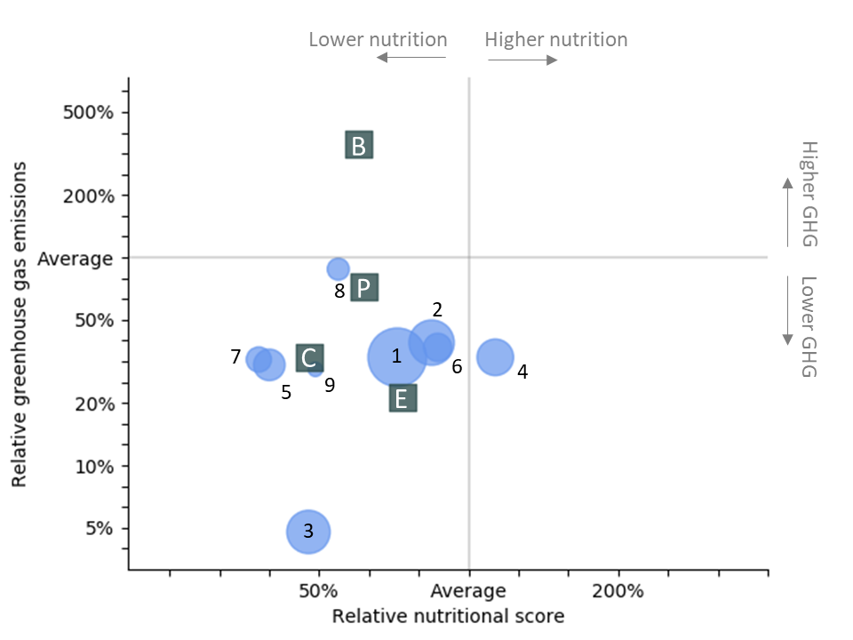

**Figure S1.** Nutritional and climate performance of the category ‘Cods, hakes, etc.’ Labeled in order of descending Swedish consumption rate: 1 – Atlantic cod; 2 – Saithe; 3 – Alaska pollock; 4 – Roe from cod; 5 – Blue grenadier (Hoki); 6 – Haddock; 7 – Cape hake; 8 – European hake; 9 – Whiting.

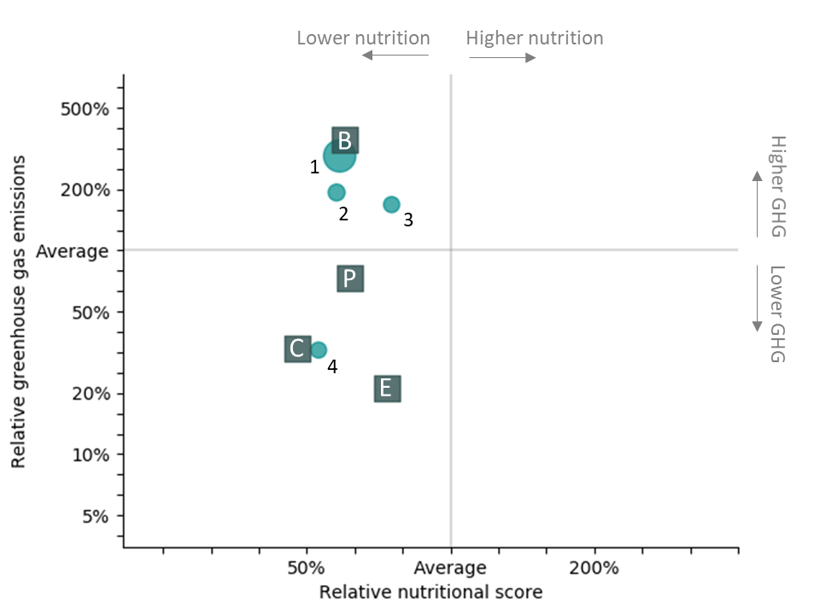

**Figure S2.** Nutritional and climate performance of the category ‘Flatfishes’. Labeled in order of descending Swedish consumption rate: 1 – Plaice; 2 – European flounder; 3 – Atlantic halibut; 4 – Turbot.

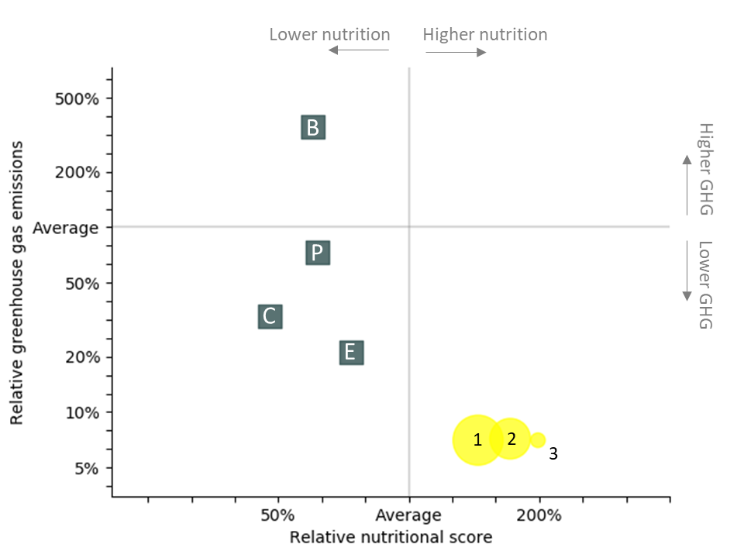

**Figure S3.** Nutritional and climate performance of the category ‘Herrings, mackerels etc.’ Labeled in order of descending Swedish consumption rate: 1 – Atlantic herring; 2 – Atlantic mackerel; 3 – European sprat.

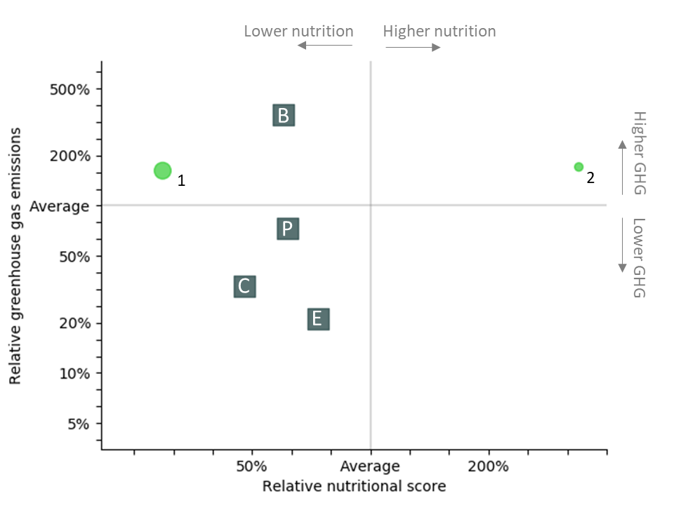

**Figure S4.** Nutritional and climate performance of the category ‘Molluscs, shellfish’. Labeled in order of descending Swedish consumption rate: 1 – Scallops; 2 – Oysters.

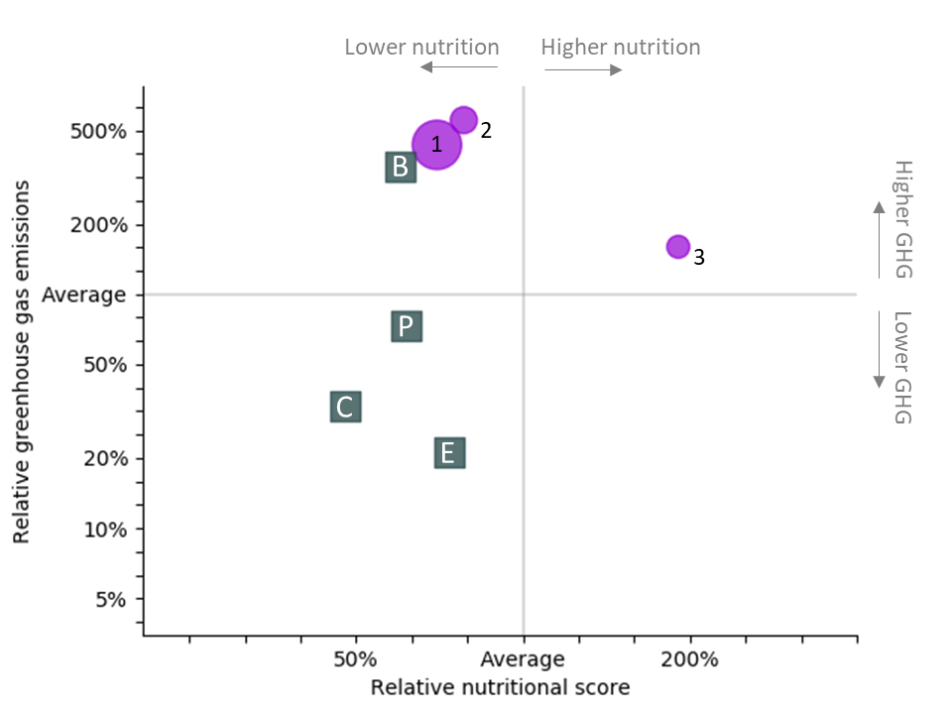

**Figure S5.** Nutritional and climate performance of the category ‘Lobsters and shrimps’. Labeled in order of descending Swedish consumption rate: 1 – Northern prawn; 2 – Norway lobster; 3 – Lobster.

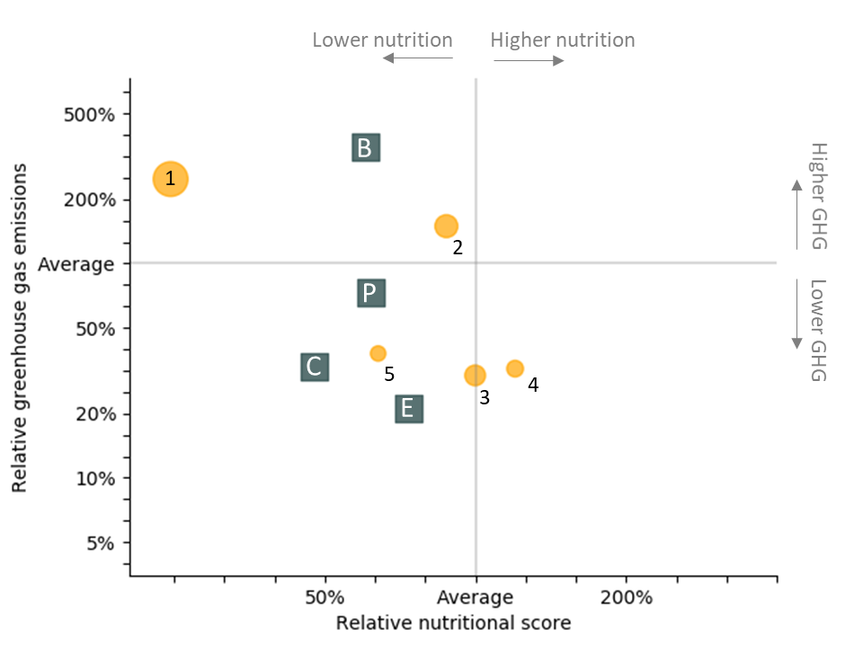

**Figure S6.** Nutritional and climate performance of the category ‘Freshwater whitefish’. Labeled in order of descending Swedish consumption rate: 1 – Pangasius; 2 – Tilapia; 3 – Pike-perch; 4 – Perch; 5 – Pike.

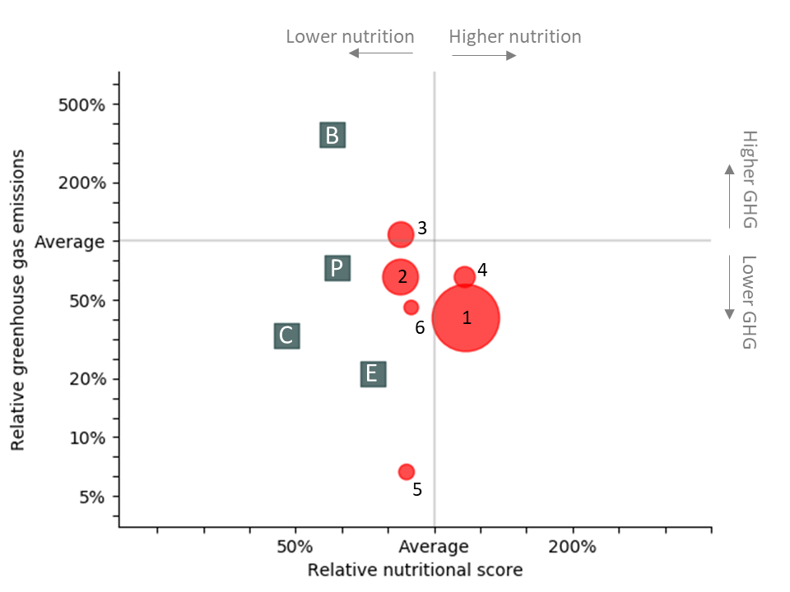

**Figure S7.** Nutritional and climate performance of the category ‘Salmon, trout’. Labeled in order of descending Swedish consumption rate: 1 – Atlantic salmon; 2 – Rainbow trout; 3 – Arctic char; 4 – Trout; 5 – Pink salmon; 6 – Coregonus.

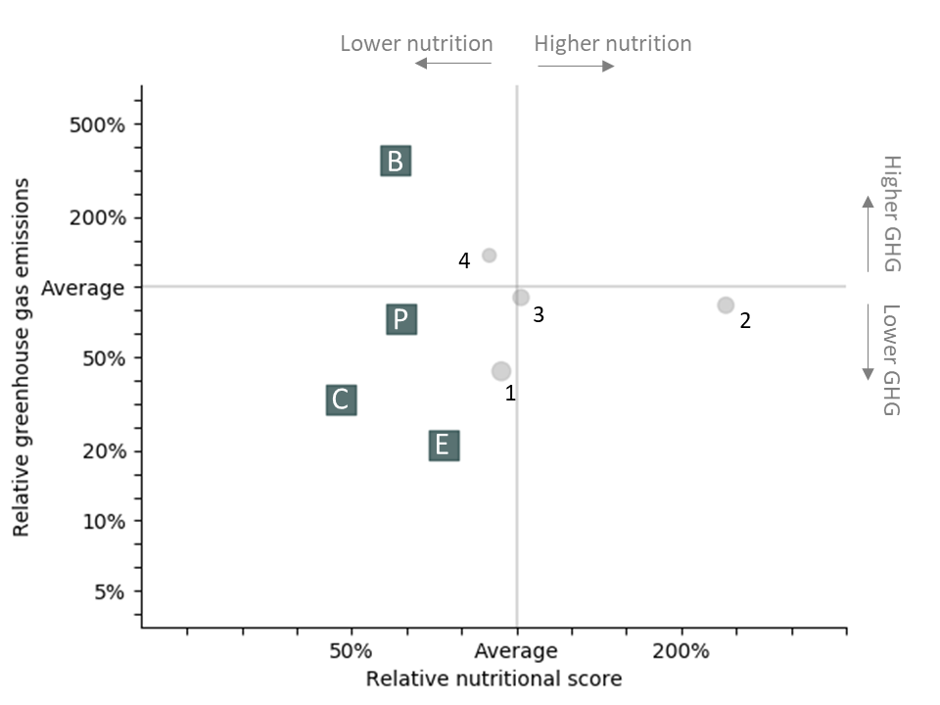

**Figure S8.** Nutritional and climate performance of the category ‘Other’. Labeled in order of descending Swedish consumption rate: 1 – Cephalopods; 2 – European eel; 3 – Gilt-head seabream; 4 – European seabass.

**References**

Abdou, K., Aubin, J., Romdhane, M. S., Le Loc'h, F., & Lasram, F. B. R., 2017. Environmental assessment of seabass (Dicentrarchus labrax) and seabream (Sparus aurata) farming from a life cycle perspective: A case study of a Tunisian aquaculture farm. Aquaculture, 471, 204-212. <https://doi.org/10.1016/j.aquaculture.2017.01.019>

Amcoff, E., Edberg, A., Enghardt Barbieri, H., Lindroos, A. K., Nälsen, M., Warensjö Lemming, E., 2012. Riksmaten - vuxna 2010-11. Livsmedels- och näringsintag bland vuxna i Sverige. (”Food and nutritional intake among Swedish adults in 2010-2011”). Swedish Food Agency. Uppsala. <https://www.livsmedelsverket.se/globalassets/publikationsdatabas/rapporter/2011/riksmaten_2010_20111.pdf> (accessed 19 July 2018)

Andersson, M., 2017. Accounting for foods’ nutritional value when implementing a climate tax on food. Master Thesis. Dep. Biosciences and Nutrition, Stockholm University, Stockholm.

Aubin, J., Papatryphon, E., Van der Werf, H. M. G., & Chatzifotis, S. (2009). Assessment of the environmental impact of carnivorous finfish production systems using life cycle assessment. Journal of Cleaner Production, 17(3), 354-361. <https://doi.org/10.1016/j.jclepro.2008.08.008>

Cederberg, C., Sonesson, U., Henriksson, M., Sund, V., Davis, J., 2009. Greenhouse gas emissions from Swedish production of meat, milk and eggs 1990 and 2005. Swedish Institute for Food and Biotechnology. Report No 793. <http://www.diva-portal.org/smash/get/diva2:943352/FULLTEXT01.pdf> (accessed 19 July 2018)

Drewnowski, A., 2009. Defining nutrient density: development and validation of the nutrient rich foods index. J. Am. College Nutr. 28, 421-426. <https://doi.org/10.1080/07315724.2009.10718106>

Drewnowski, A., Fulgoni, V. L., 2014. Nutrient density: principles and evaluation tools. Am. J. Clin. Nutr. 99, 1223-1228. <https://doi.org/10.3945/ajcn.113.073395>

Driscoll, J., Boyd, C., & Tyedmers, P. 2015. Life cycle assessment of the Maine and southwest Nova Scotia lobster industries. Fish Res, 172, 385-400. <https://doi.org/10.1016/j.fishres.2015.08.007>

DTU, 2018. Frida ver. 3A. Copenhagen, Danish Technical University, Fodevareinstituttet. Copenhagen. <https://frida.fooddata.dk/GrpList.php> (accessed 19 July 2018)

FAO, 2018. FishStatJ. Software for fishery statistical time series.

Fiskeridirektoratet, 2018. Landa fangst fordelt på redskap (”Landed catch per gear”). Directorate of Fisheries, Norway. https://www.fiskeridir.no/Yrkesfiske/Statistikk-yrkesfiske/Fangst-og-kvoter/Landa-fangst-fordelt-paa-redskap (accessed 24 July 2018)

Fulton, S., 2010. Fish and Fuel: Life cycle greenhouse gas emissions associated with Icelandic cod, Alaskan pollock, and Alaskan pink salmon fillets delivered to the United Kingdom. <http://hdl.handle.net/10222/13042> (accessed 25 July 2018)

Hallström, E., Davis, J., Woodhouse, A., Sonesson, U., 2018. Using dietary quality scores to assess sustainability of food products and human diets: A systematic review. Ecol. Indic. 93, 219-230. <https://doi.org/10.1016/j.ecolind.2018.04.071>

Hallström, E., Röös, E., Börjesson, P., 2014. Sustainable meat consumption: a quantitative analysis of nutritional intake, climate impact and land use from a swedish perspective. Food Policy 47, 81-90. <https://doi.org/10.1016/j.foodpol.2014.04.002>

Hilborn, R., & Tellier, P., 2012. The environmental cost of New Zealand food production. New Zealand Seafood Industry Council Ltd, Wellington, New Zealand. https://www.seafoodnewzealand.org.nz/fileadmin/documents/other_publications/ECNZFP-2012.pdf [10.1016/j.foodpol.2014.04.002](http://dx.doi.org/10.1016/j.foodpol.2014.04.002) [10.1016/j.foodpol.2014.04.002](http://dx.doi.org/10.1016/j.foodpol.2014.04.002)

IFR, 2018. Composition of Foods Integrated Dataset (CoFID), version from 2015.Institute of Food Research, Public Health England, London. <https://www.gov.uk/government/publications/composition-of-foods-integrated-dataset-cofid> (accessed 19 July 2018)

IPCC, 2007. Summary for policymakers. In Climate Change 2007: Mitigation. Contribution of Working Group III to the Fourth Assessment Report of the Intergovernmental Panel on Climate Change, pp. 1-24 (B Metz, OR Davidson, PR Bosch, R Dave and LA Meyer, editors). Cambridge: Cambridge University Press. <http://www.ipcc.ch/pdf/assessment-report/ar4/wg3/ar4-wg3-spm.pdf>. (accessed 10 July 2018)

NCM, 2014. Nordic Nutrition Recommendations 2012. Nordic Council of Ministers, Nord, Copenhagen. <https://www.norden.org/en/theme/former-themes/themes-2016/nordic-nutrition-recommendation/nordic-nutrition-recommendations-2012> (accessed 19 July 2018)

Nifes (2018). Seafood data. Institute of Marine Reserach. Bergen. <https://sjomatdata.nifes.no/#search/> (accessed 19 July 2018)

Öhrvik, V., Engman, J., von Malmborg, A., Wretling, S., 2013. Kött - analys av näringsämnen (”Meat- analysis of nutrients”). Swedish Food Agency. Uppsala. <https://www.livsmedelsverket.se/globalassets/publikationsdatabas/rapporter/2013/2013_livsmedelsverket_24_kott_analys_av_naringsamnen.pdf> (accessed 19 July 2018)

Parker, R. W. R., Tyedmers, P. H., 2015. Fuel consumption of global fishing fleets: current understanding and knowledge gaps. Fish Fish, 16(4), 684-696. <https://doi.org/10.1111/faf.12087>

Parker, R.W.R., Blanchard, J.L., Gardner, C., Green, B.S., Hartmann, K., Tyedmers, P.H., Watson, R.A., 2018. Fuel use and greenhouse gas emissions of world fisheries. Nature Clim. Change 8, 333-337. <https://doi.org/10.1038/s41558-018-0117-x>

Pelletier, N., Tyedmers, P., Sonesson, U., Scholz, A., Ziegler, F., Flysjö, A., Kruse, S., Cancino, B., Silverman, H., 2009. Not all salmon are created equal: Life Cycle Assessment (LCA) of global salmon farming systems. Environmental Science and Technology 43(23), 8730-8736 https://doi.org/10.1021/es9010114

Ramos, S., Ian, V. Ã., Artetxe, I. A., Moreira, M. T., Feijoo, G., & Zufia, J., 2014. Operational efficiency and environmental impact fluctuations of the Basque trawling fleet using LCA+ DEA methodology. Turkish Journal of Fisheries and Aquatic Sciences, 14(1).

Saarinen, M., Fogelholm, M., Tahvonen, R., Kurppa, S., 2017. Taking nutrition into account within the life cycle assessment of food products. J. Clean. Prod. 149, 828-844. <https://doi.org/10.1016/j.jclepro.2017.02.062>

Samuel-Fitwi, B., Nagel, F., Meyer, S., Schroeder, J. P., & Schulz, C., 2013. Comparative life cycle assessment (LCA) of raising rainbow trout (Oncorhynchus mykiss) in different production systems. Aquacultural engineering, 54, 85-92. <https://doi.org/10.1016/j.aquaeng.2012.12.002>

SARF, 2012. Carbon Footprint Of Scottish Suspended Mussels And Intertidal Oysters. <http://www.sarf.org.uk/cms-assets/documents/43896-326804.sarf078> (accessed 25 July 2018)

SFA, 2018. Livsmedelsdatabasen (”The Food Database”). Swedish Food Agency. <https://www.livsmedelsverket.se/livsmedel-och-innehall/naringsamne/livsmedelsdatabasen> (accessed 17 July 2018)

Silvenius, F., Grönroos, J., Kankainen, M., Kurppa, S., Mäkinen, T., Vielma, J., 2017. Impact of feed raw material to climate and eutrophication impacts of Finnish rainbow trout farming and comparisons on climate impact and eutrophication between farmed and wild fish. Journal of Cleaner Production, 164, 1467-1473. <https://doi.org/10.1016/j.jclepro.2017.07.069>

SLU, 2018. Fisk- och skaldjursbestånd i hav och sötvatten 2017. Resursöversikt. (”Fish and seafood stocks in the sea and fresh water 2017. Resource overview”) https://www.slu.se/globalassets/ew/org/inst/aqua/externwebb/sidan-publikationer/resurs-och-miljo/fisk-och-skaldjursbestand-i-hav-och-sotvatten-2017-resursoversikt.pdf (accessed 24 July 2018)

Sluik, D., Streppel, M. T., van Lee, L, Geelen, A., Feskens, E. J. M., 2015. Evaluation of a nutrient-rich food index score in the Netherlands. J. Nutr. Sci. 4, 1-9. <https://doi.org/10.1017/jns.2015.4> (accessed 19 July 2018)

Thrane, M., 2004. Environmental impacts from Danish fish products: Hot spots and environmental policies. Institut for Samfundsudvikling og Planlægning, Aalborg Universitet.

Ziegler, F., Bergman, K., 2017. Svensk konsumtion av sjömat- en växtande mångfald (”Swedish seafood consumption- a growing diversity”, Research Institutes of Sweden. Agrifood and Bioscience. Göteborg. http://ri.diva-portal.org/smash/record.jsf?pid=diva2%3A1094275&dswid=998 (accessed 19 July 2018)

Ziegler, F., Groen, E. A., Hornborg, S., Bokkers, E. A., Karlsen, K. M., de Boer, I. J., 2018. Assessing broad life cycle impacts of daily onboard decision-making, annual strategic planning, and fisheries management in a northeast Atlantic trawl fishery. I J LCA 23(7):1357-1367

Ziegler, F., Valentinsson, D., 2008. Environmental life cycle assessment of Norway lobster (*Nephrops norvegicus*) caught along the Swedish west coast by creels and conventional trawls—LCA methodology with case study. I J LCA. 13(6), 487. https://doi.org/[10.1007/s11367-008-0024-x](https://doi.org/10.1007/s11367-008-0024-x)

Ziegler, F., Winther, U., Hognes, E. S., Emanuelsson, A., Sund, V., Ellingsen, H., 2013. The carbon footprint of Norwegian seafoods on the global seafood market. Journal of Industrial Ecology, 17(1), 103-116. <https://doi.org/10.1111/j.1530-9290.2012.00485.x>